CAMBRIDGE ROTARY CLUB
THURSDAY - 12:15 PM

RYLES JAZZ CLUB
212 HAMPSHIRE STREET - INMAN SQUARE
CAMBRIDGE

FELLOWSHIP NEWS

APRIL 16, 2007

LET US LEAD THE WAY

THIS WEEK AT ROTARY

MASSACHUSETTS WATER RESOURCES AUTHORITY (MWRA)

Fred Laskey is Executive Director of the MWRA. A resident of Medford, Fred has been leading the MWRA since 2001. Prior to his current position he served as Commissioner of Revenue for the Commonwealth of Massachusetts. He is also a veteran leader in the Boy Scout program. Currently he is the Commissioner of the Boston-Minuteman Council, BSA.

MWRA is a Massachusetts public authority established by an act of the Legislature in 1984 to provide wholesale water and sewer services to 2.5 million people and more than 5,500 large industrial users in 61 metropolitan Boston communities.

MWRA Water System - Every day Eastern Massachusetts residents quench their thirsts, bathe, flush toilets, do the dishes and water their lawns with water drawn from the MWRA water system.
Thanks to the Quabbin and Wachusett Watersheds and Reservoirs, 2.2 million people and 5,500 industrial users have one of the most abundant and high quality water supplies in the world.

MWRA Sewer System – The sewage treatment system has undergone a nearly complete transformation under the federally mandated 11-year, $3.8 billion Boston Harbor Project. The project, which is now complete, included a new sludge-to-fertilizer facility; the Deer Island Treatment Plant with primary and secondary treatment capabilities; the Inter-Island Tunnel that tied together two separate sewer systems (North and South) into one; and the 9.5-mile Effluent Outfall Tunnel to discharge treated wastewater away from shallow Boston Harbor waters and into the deeper waters and stronger currents of Massachusetts Bay.
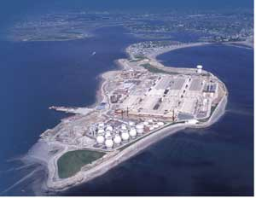
The Deer Island Treatment Plant removes human, household, business and industrial pollutants from wastewater that originates in homes and businesses in 43 greater Boston communities. In compliance with all federal and state environmental standards and subject to the precedent-setting discharge permit issued for the plant by EPA and DEP, it's treated wastewater can be released to the marine environment.

LAST WEEK AT ROTARY

PRESIDENT-ELECT MARC O’BRIEN opened the meeting with the Pladge of Allegiance. DAN O’NEILL led us in song and JUSTIN SLATE offered the blessing.

HAPPY DOLLARS
Your editor was busy and missed most of the donations. However, he did hear:

SUSAN LAPIERRE say - since SAL SAGARESE, from Cambridge Trust (our friendly competitor) is not here today, she can CONTINUE TO BRAG about how great the North Cambridge, Mass Ave Office of East Cambridge Savings Bank is doing! And to remind everyone, that if the Red Sox game is rained out tonight, remember the best event in town tonight is the Cambridge Housing Assistance Fund's (CHAF) Spring Fling at the Hyatt Regency. Join us to help prevent Cambridge individuals and families from becoming homeless.

CLUB NOTES

JACKIE LARSEN has a new business address:
Biogen Idec
14 Cambridge Center
Cambridge, MA 02141
617-679-6489
email address jackie.larsen@biogenidec.com

Thank you PPJUSTIN SLATE for your generous contribution to our Rotary Education Fund on the
occasion of your birthday.

Our Sergeant at arms this week will be KEVIN GHIOZZI.

Peabody Rotary has a new location for their luncheon meetings, effective Tuesday April 10th, at 12:00PM they are meeting at: Wardhurst Steakhouse 31 Lynnfield Street, Peabody

Anyone planning on attending the Rotary International Convention please contact Secretary DAN O’NEILL.

RAFFLE

Thank you ED VER PLANCK, MALLORY SLATE, BARRY SEIDMAN, SAL SAGARESE, TOM LYNN and everyone who donates items to our weekly raffle. Without your support we would have nothing to raffle and we would lose an important segment of our meeting. Last week BARRY donated an item that DENISE had difficulty identifying. She asked MALLORY if he donated the item and he said: “No, we took those off our shelves 4 years ago.” The next item, DENISE asked BARRY if he donated the stationery item, not to be out done – BARRY said no because “He took that item off the shelves 5 years ago.” Friendly banter between the two leading stationery businesses in Cambridge.

CHANGE AT ROTARY THIS WEEK

In an effort to make RYLES more comfortable for our meeting we will re-configure the room. Our dining tables will be near the piano, facing the wall where the buffet food line is normally located. The buffet line will be located in the area where our President normally conducts the meeting.

The new location offers better lighting and a better atmosphere for fellowship. And we will provide an improved area for our speakers. We hope you will like the new dining format.

CHALK ON THE WALK

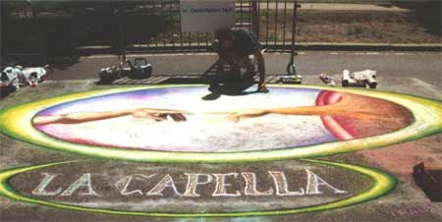

Sunday, May 6 is around the corner. Our leadership team of JACKIE LARSEN, AMY CROOT and KEVIN GHIOZZI are working diligently to make sure our major fund raising event of the year is a great success.

You can help by:
• Sponsoring a square – Different prices – All on Church St.
• Making a contact and securing a sponsor. Forms in your kit.
• Contacting an artist, sign them up and tell our leadership team.
• Volunteering to help for a few hours on Sunday, May 6 clean-up at 4.
• Help from 10 to 3 with crowd control, assigning artists, etc.
• Bring you wife, partner, children, grandchildren, it’s a great day.

Contact Jackie, Amy or Kevin and volunteer – Rotary depends on you!
Jackie - jackie.larsen@biogenidec.com
Amy - amycroot@yahoo.com
Kevin - KGhiozzi@barrellplumbing.com

FUTURE PROGRAM
Our annual luncheon for the members of the National Honor Society at Cambridge Rindge and Latin School will be held on Thursday, April 26. We will host the NHS students and faculty for a delicious meal served by the staff of RYLES. Plan to attend and met the future leaders of our community and country. ALICE McCARTER assisted by AMY CROOT is providing leadership for the luncheon program.

PLEASE NOTE

PRESIDENT DENISE requests that no more than two (2) Rotarians sit at a table. In other words we should sit with the students and engage them in conversation. Please make an effort to comply with this request.

Remember, you were a student once upon a time and you would have enjoyed the opportunity to engage an adult in conversation.

PROGRAM

INTERNATIONAL INSTITUTE of BOSTON (IIB) Carolyn Benedict-Drew, President of the Internationall Institute of Boston (IIB).. Founded in 1924, IIB helps immigrants and refugees successfully integrate into New England.

Fundamental to all of the Institute's programs is the promotion of self-sufficiency – giving clients the tools to help themselves become active participants in the social, political and economic richness of American life.

The Institute provides newcomers with direct and practical assistance in the form of English & literacy courses, Refugee Resettlement services, Citizenship Education, Economic Development, Employment Training & Placement, Legal Aid and Social Services (e.g. crisis intervention, mental health counseling, human trafficking prevention). This past year alone nearly 10,000 people from over 130 lands – representing all regions of the world – received services through the Institute's three sites in Manchester NH, Lowell MA and Boston MA. In Boston, IIB serves approximately 7,000 persons each year through programs that are all available in one central location, One Milk Street.

The U.S. has a tradition of opening its doors to those looking to make a new home on its shores and our nation has benefited from this culturally and financially.

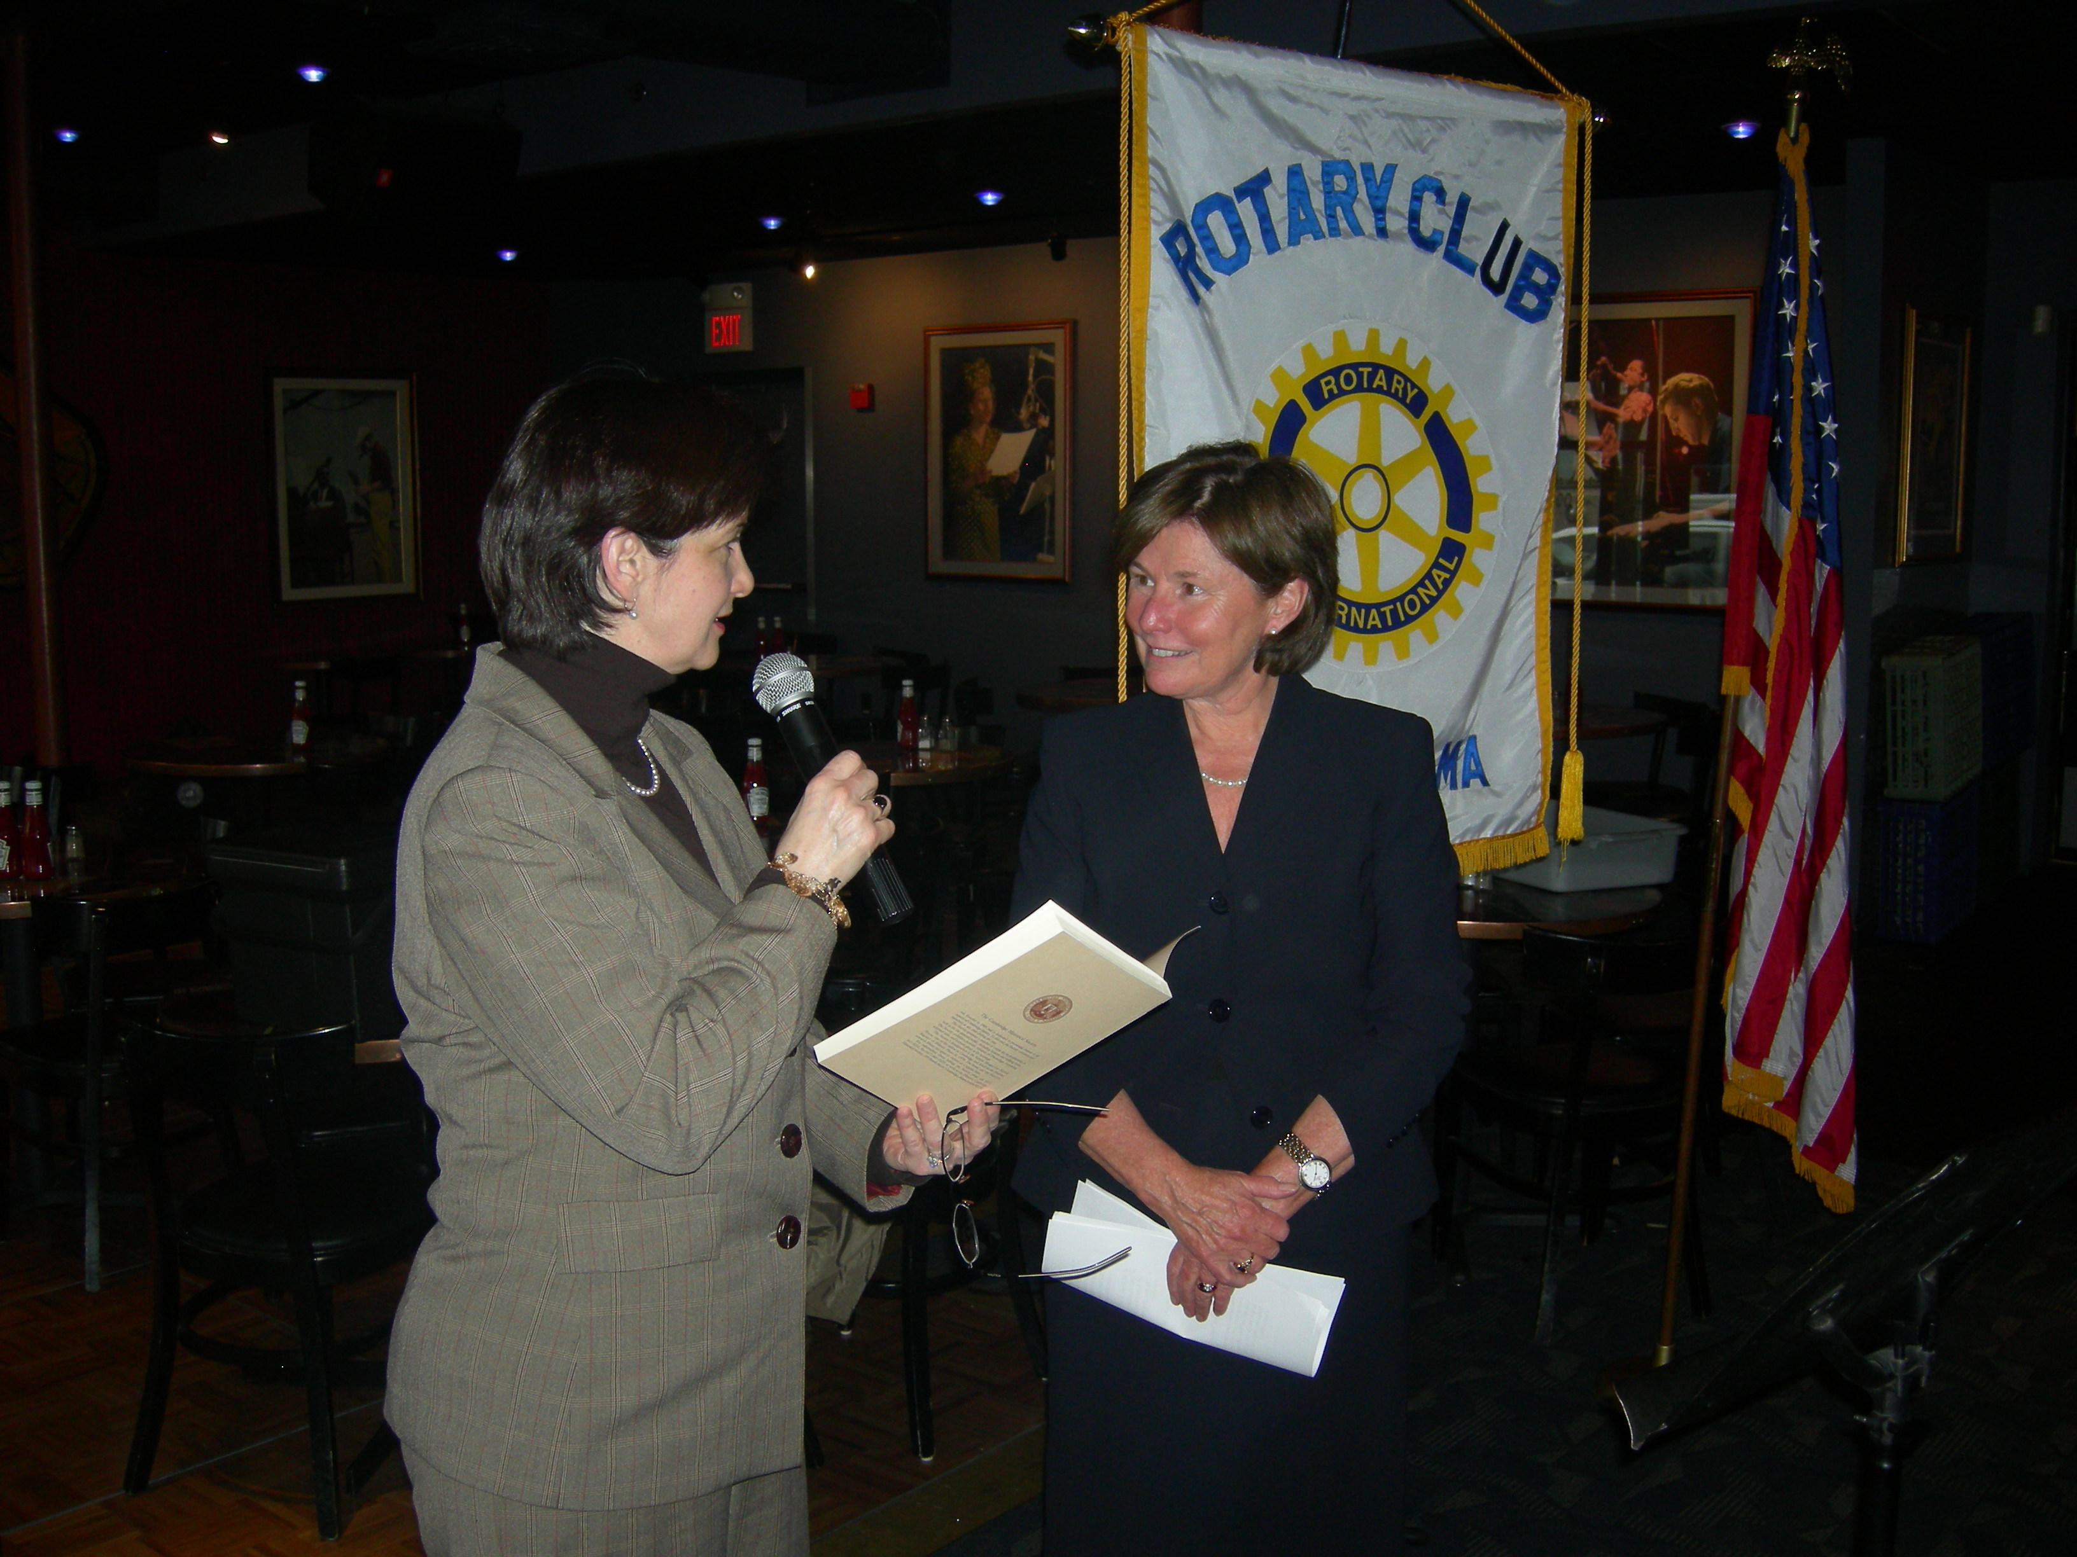

Today’s immigrants and refugees carry the same entrepreneurial sprit, commitment to family and
immense love for their new home that were the leading characteristics of the waves of newcomers that came before. The immigrants and refugees that IIB serves arrive in the U.S. to rebuild their lives, fully prepared to become contributing neighbors, fellow employees and even our leaders of tomorrow.

SEE YOU AT RYLES ON THURSDAY
COME AND SEE THE NEW SEATING PLAN

THURSDAY, APRIL 19, 2007

12 NOON

Dan O’Neill
Editor

