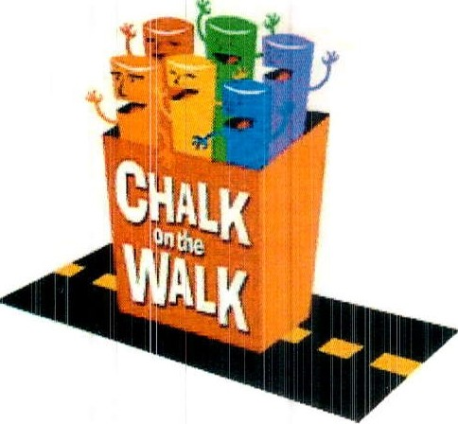

## CHALK ON THE WALK

## Presented by the Rotary Club of Cambridge

## ARTIST PARTICIPATION FORM

Yes, I want to help the Rotary Club of Cambridge continue “to do good in the community!”

Please sign me up to create a chalk painting at Cambridge Rotary’s "Chalk on the Walk."

Sunday, October 12, 2025, in Harvard Square during Oktoberfest. **PARTICIPATION IS FREE!**

**Name** (required)

**E-mail** (required)  **Phone**

**Please select the size painting you wish to create:**

**___** 5' x 7'

**___** 6' x 8'

**___** 7' x 9'

**__** 8' x 10'

No preference

Please note that we will do our best to match you with a square of your selected choice, but we may need to assign you to an alternate size based on sponsor sign-ups.

Cambridge Rotary will find a square sponsor for you, but if you wish to find your own sponsor, please let us know.

**Please initial all lines below (required):**

**___**I acknowledge that I have reviewed and will comply with the guidelines as outlined in the FAQs found on the Rotary Club of Cambridge website:

<http://CambridgeRotary.org/ChalkFAQ.cfm>

**__** I further agree thatmyartwork must be appropriate for public viewing. No words or symbols intended as advertising may appear within the image. We supply washable sidewalk-type chalk and pastels; however, it is permitted for you to bring your own chalk as long as they are okay for sidewalk use (no acrylics, no liquids).

**__** I acknowledge thatChalk on the Walk is entitled to photograph and reproduce the street painting created by me (and my helpers) in any manner.

Please email this signed form back to us at [chalk@cambridgerotary.org](mailto:chalk@cambridgerotary.org). Though walk-ins are welcome, we would appreciate your response by October 5th so that we can plan the square sizes.

**THANK YOU!**

**We will e-mail you useful tips and registration information prior to the event**

For more information, call Joe Kobialka at 617-974-5336 or e-mail us at chalk@cambridgerotary.org