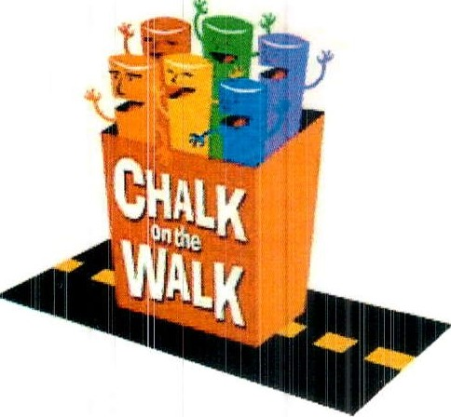

CHALK ON THE WALK

Presented by the Rotary Club of Cambridge

ARTIST PARTICIPATION FORM

Yes, I want to help The Rotary Club of Cambridge to continue “to do good in the community!”
Please sign me up to make a chalk painting at Cambridge Rotary’s "Chalk on the Walk"
in Harvard Square during Oktoberfest, Sunday, October 8, 2023

PARTICIPATION IS FREE!
Please return this form by Monday, October 2, 2023

Name (required)
E-mail (required) Phone

Please select the size painting you wish to do:
___ 5' x 7'
___ 6' x 8'
___ 7' x 9'
__ 8' x 10'
No preference

Please note that we will do our best to match you with a square of your selected choice, but we may need to assign you to an alternate size based upon sponsor sign ups.

Cambridge Rotary will find a square sponsor for you, but if you wish to find your own sponsor, please let us know.

Please initial all lines below (required):
__ I acknowledge that I have reviewed and will comply with the guidelines as outlined in the FAQs found on the Rotary Club of Cambridge website:
http://CambridgeRotary.org/ChalkFAQ.cfm
___ I further agree that my artwork must be appropriate for public viewing. No words or symbols intended as advertising may appear within the image. We supply washable sidewalk-type chalk and pastels; however, it is permitted for you to bring your own as long as they are okay for sidewalk use (no acrylics, no liquids).
__ I acknowledge that Chalk on the Walk is entitled to photograph and reproduce the street painting created by me (and my helpers) in any manner.

THANK YOU!
We will e-mail you useful tips and registration information prior to the event
For more information, call Joe Kobialka at 617-974-5336 or e-mail us at chalk@cambridgerotary.org

