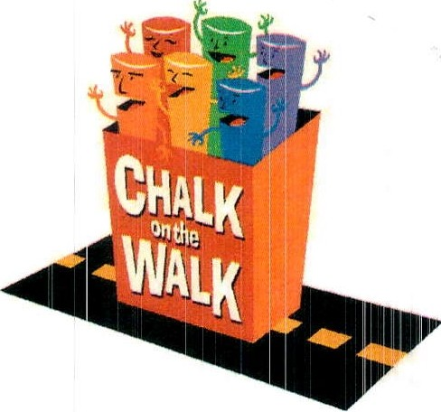

CHALK ON THE WALK

Presented by the Rotary Club of Cambridge

at Oktoberfest in Harvard Square

on Sunday, October 8, 2023

SPONSOR PARTICIPATION FORM
Yes! I want to be a Chalk on the Walk sponsor so that the Rotary Club of Cambridge can continue
“to do good in the community.” I look forward to seeing my company's name displayed
above an artist's chalk painting.
Name to appear above the chalk drawing: ______________________________________________________
Contact Name _______________________________ Phone
Address ___________________________ E-mail______________________________

Square Size | 5' X 7' | 6' X 8' | 7' X 9' | 8’ x 10’ | 8’ x 10’  CHAMPION SPONSOR
Square Price | $300 | $500 | $750 | $1,000 | $1,500
# of Squares

ARTIST INFORMATION - check your preference:
☐
I will send my own artist(s); please have your artist(s) complete an Artist Participation Form
- available online at www.cambridgerotary.org.
☐
Please match me with an artist(s)
PAYMENT INFORMATION - check your preference:
Enclosed is a check payable to Cambridge Rotary Educational Fund, Inc.
☐
[Note: The Cambridge Rotary Educational Fund is a 501(c)3 tax exempt organization.] OR

□ Please click link here to pay. (Ctrl + Click). Please consider adding 3% to cover the surcharge.
□ Please send me an invoice

Please return this form no later than Monday, September 25, 2023 to:

Info@cambridgerotary.org

or mail to: Cambridge Rotary Club, 36 Gray Street, Cambridge MA 01238

Please refer to the FAQs found on the Rotary Club of Cambridge website (www.cambridgerotary.org) for event guidelines. For more information e-mail us at info@cambridgerotary.org

Thank you very much for your sponsorship

